Dessa Shapiro

3/1/20

Period 4/6

Slaves

I’m reading the book a long way away from Ishmael Beach. This book is a true story about a boy named Ishmael who was forced to leave his home and live and eventually fight to survive the war. Along the way, he loses many loved one and I am manipulated to do horrible things. I think the author is trying to express childhood as a change and trying to show that children's minds can change and shift with the help of others. In this section of the book, Ishmael had just been moved from the army into a rehabilitation facility for child soldiers and they had just arrived and are just now meeting the other boys “And who the Fuck are you? Do we look like we are here to answer questions for bastar pekin lek you” He leaned across the table and looked down on Alhaji. Alhaji got up and pushed him.”(P. 133)

I think that this passage shows that Ishmael even though he was still only a child has been scared and greatly affected by the war. Through the war, he had been manipulated and brainwashed into wanting revenge for his parents and killing because as easy as drinking water for him. You can also tell that he doesn't trust people and still thinks of his life as a war zone. Later in this chapter, Ishmael has been in the rehabilitation facility for a longer amount of time and he has met a nice nurse who has taken care of him through his nightmares and PTSD he is suffering from. “None of these is your fault”….I began that day to believe it. It was the genuine tone in Esther’s voice that made that phrase sink into my mind and heart.”(Pg. 165) This passage shows how Ishmael has been changing over time. When Ishmael was in the war he didn't have positive adult figures that treated like a kid and listened to him, but when he met the nurse she would listen to him and give him gifts like a New cassette tape which indicated his childhood returning. Over time he starts to trust her and starts to change by gaining more empathy for others and thinking about the war and his family.

Overall I think that it is very important to apply this to how our society is today and how we treat children. Children all over the world are being denied their rights to education and safety. Many children are taken advantage of with child labor, sex trafficking ex. And all these things can affect how their brains develop, and the same thing that happened to Ishmael is still happening all over the world. These children are scared and traumatized by the things they've been through and when they are removed from a situation or taken in by someone, they aren't understood. People can't rush these children into rehabilitation centers or mental hospitals without understanding what they've been through. Usually, children get comfort from their parents and when they are separated from them they can lose their humanity and identity. So we as a society have to understand how delicate children are that we have to be patient and calm with them.

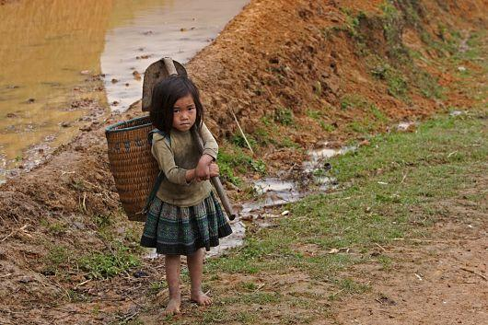

This Is a picture I found of childlabor and it shows an example of how people are treating children as tools.